**H.H THE RAJAH’S COLLEGE**

**PUDUKKOTTAI – 622 001**

**DEPARTMENT OF MATHEMATICS**

**NAAN MUDHALVAN – SMART BRIDGE PROJECT**

**PROJECT TITLE**

**RECRUITING ASSISTANT FOR HR MANAGERS**

**SUBMITTED BY**

|  |  |  |  |
| --- | --- | --- | --- |
| TEAM LEADER | : | ARUNKUMAR R | (20ME 2205) |
| TEAM MEMBER 1 | : | BHARATHI K | (20ME 2208) |
| TEAM MEMBER 2 | : | JAYABALAN M | (20ME 2213) |
| TEAM MEMBER 3 | : | SIVAKUMAR R | (20ME 2231) |

**Faculty Mentor**

**Dr. R. Muthuraj**

Assistant Professor of Mathematics

H. H. The Rajah’s College, Pudukkottai – 622 001.

**INDEX**

|  |  |  |  |
| --- | --- | --- | --- |
| **S.NO** |  | **CONTENT** | **PAGE NO** |
| **1** | **Introduction** | | 3 |
| **1.1** | Overview | 4 |
| **1.2** | Purpose | 4 |
| **2** | **Problem Definition & Design Thinking** | | 5 |
| **2.1** | Empathy Map | 5 |
| **2.2** | Ideation & Brainstorming Map | 7 |
| **3** | **Result** | |  |
| **3.1** | Data Model | 8 |
| **3.2** | Activity & Screenshot | 9 |
| **4** | **Trailhead Profile Public URL** | | 11 |
| **5** | **Advantages & Disadvantages** | | 11 |
| **6** | **Applications** | | 12 |
| **7** | **Conclusion** | | 13 |
| **8** | **Future Scope** | | 14 |

Trailhead Profile Public URL18

**INTRODUCTION**

In this project, we use custom objects, relationships, page layouts to give

the HR team easy access to data they need on an existing recruitment app. To make the existing app more efficient for the HR team we create custom objects and relationships to store and access the data more efficiently. We install an unmanaged package in the org to get metadata that acts as existing data in the recruitment app.

**Recruitment Assistant responsibilities include:**

* Supporting recruiting teams with clerical duties
* Scheduling interviews and balancing calendars for interviewers and candidates
* Helping with initial applicant screening
* Job brief
* We are looking for a Recruitment Assistant to support our recruiting and onboarding activities.
* Recruitment Assistant responsibilities include scheduling calls and interviews, maintaining candidate database and handling paperwork. Ultimately, you’ll help us hire efficiently and keep our hiring process running.
* If you have some experience in recruiting and you’re an excellent organizer and communicator, we’d like to meet you.

**Responsibilities**

* Coordinate hiring activities
* Undertake clerical duties (e.g. answering emails and drafting offer letters)
* Prepare and post job ads online
* Help with resume screening and initial phone screens
* Schedule interviews and keep calendars for all hiring teams and candidates
* Greet and assist interviewees onsite

**1.1 OVERVIEW**

An HR Assistant will be responsible for managing and handling the day-to-day HR activities. HR Assistant will also be responsible for identifying any payroll issues and miscalculations. In addition to this, HR Assistant should be able to update and maintain employees' details in both online and offline mode. To be successful in this job role, HR Assistant should have an exceptional ability to solve problems instantly. HR Assistant should also possess outstanding people skills and the ability to maintain sensitive information. Moreover, HR Assistant should also be updated with the latest HR trends and practices. In this Project, we have to create an app to recruit a candidate who can perform this job role HR Assistant.

**1.2 PURPOSE**

A Human Resources (HR) Assistant is a professional who is responsible for the daily administrative and HR duties of an organization. They assist with recruitment and record maintenance for payroll processing as well as provide clerical support to all employees.

**PROBLEM DEFINITION & DESIGN THINKING :**

**2.1 EMPATHY MAP :**

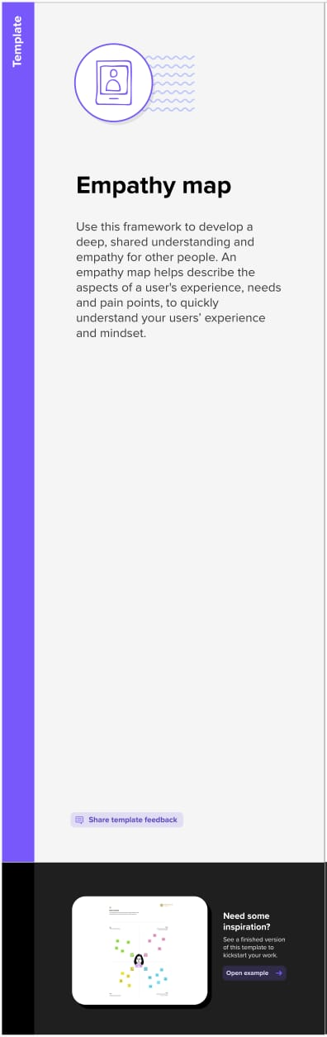

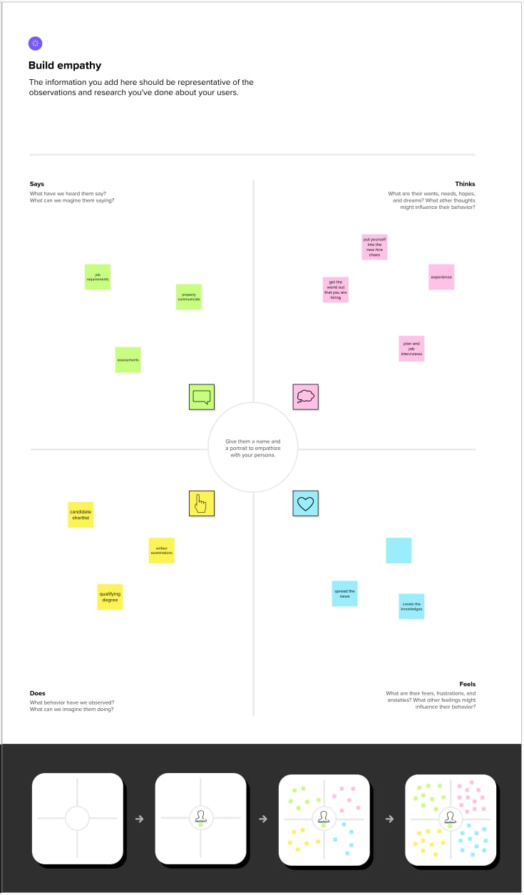**2.2 IDEATION & BRAIN STORMING MAP :**

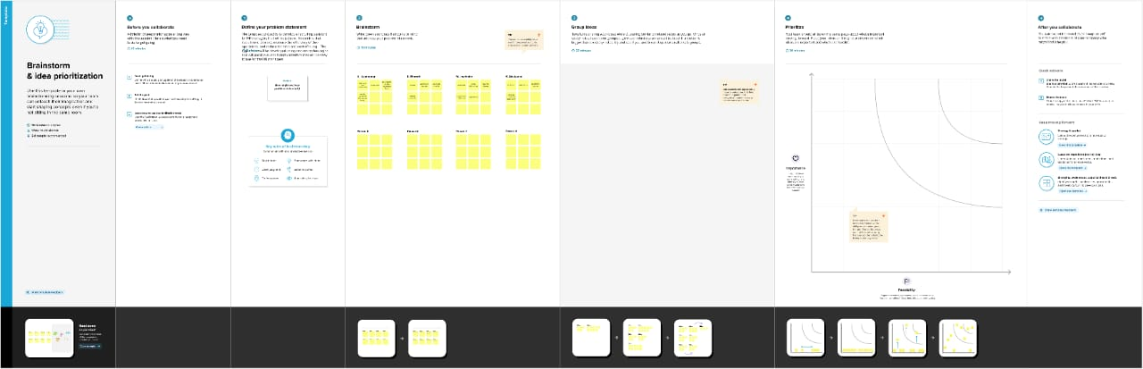

**3. RESULT :**

**ITIES**

**DATA MODEL :**

|  |  |
| --- | --- |
| **Object Name** | **Fields in the object** |
| **Object 1**    **Job Posting Site** | |  |  | | --- | --- | | **Field Label** | **Data Type** | | Status | Text | | Job posting site URL | Select URL | | Position | Text | | Status | Text | | Technical Site | Text | | Decription | Text | |
| **Object 2**  **Reviews** | |  |  | | --- | --- | | **Field Label** | **Data Type** | | Review Number | Auto Number | |
| **Object 3**  **Junction Object** | |  |  | | --- | --- | | **Field Label** | **Data Type** | | Job Posting Number | Auto Number | |

**3.2 Activity & Screenshot**

**Object 1** **: Job Posting Site**

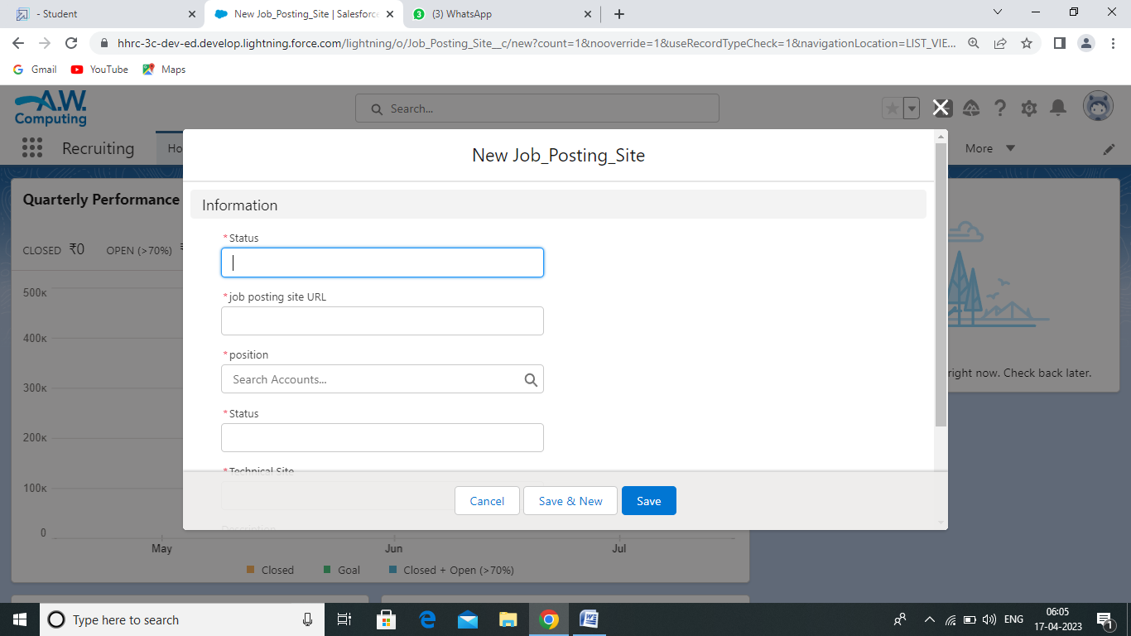

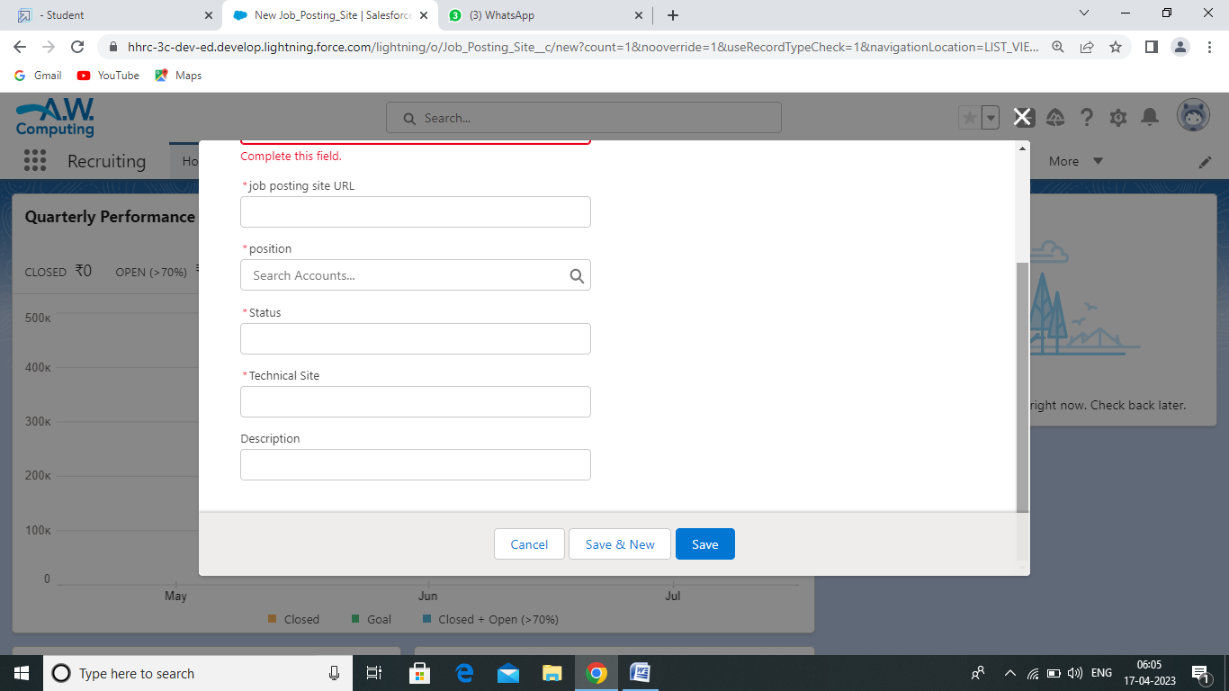

Job posting sites use a range of methods to connect job seekers.

Object 2 : Review

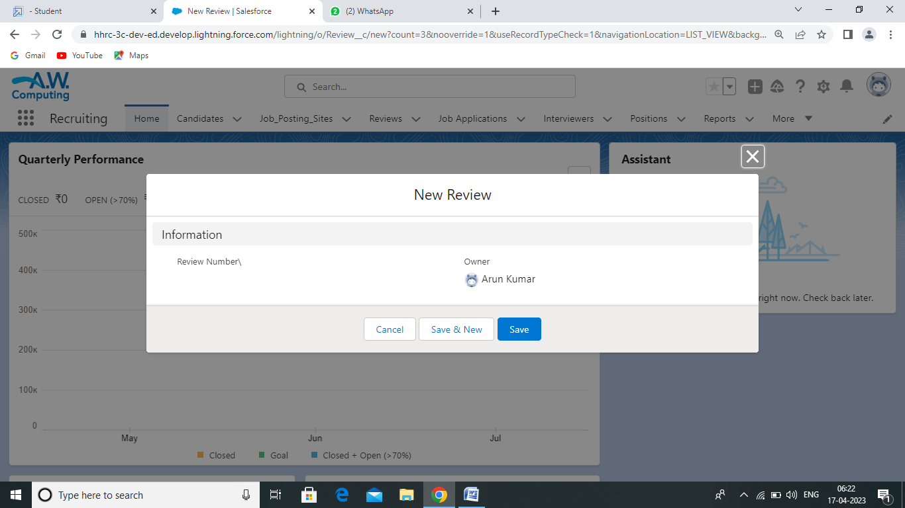

Review manager will lead and direct the routine function of the HR.

Object 3 : Junction Object

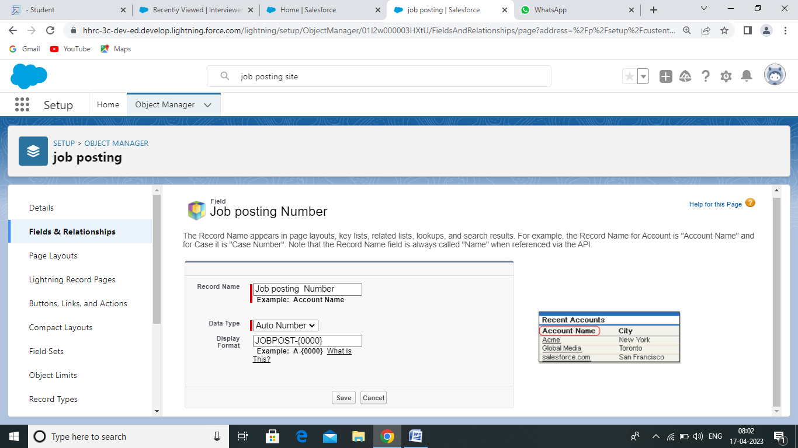

A Junction object is a custom object with two master detail relationships.

**4 Trailhead Profile Public URL**

Team Lead : <https://trailblazer.me/id/akumar8378>

Team Member 1 : <https://trailblazer.me/id/roman43213>

Team Member 2 : <https://trailblazer.me/id/jbalan21>

Team Member 3 : <https://trailblazer.me/id/skumar9362>

**5**  **ADVANTAGE & DISADVANTAGE**

**Advantages:**

* **Time-saving** : Recruiting assistants can help HR managers save time by handling administrative tasks such as posting job ads, scheduling interviews, and screening resumes.
* **Cost-saving** : Recruiting assistants can be a cost-effective solution for companies that cannot afford to hire a full-time HR staff member.
* **Improved candidate experience** : Recruiting assistants can help provide a better candidate experience by ensuring that candidates receive timely and clear communication about the recruitment process.
* **Increased efficiency** : Recruiting assistants can help HR managers streamline their recruitment processes by handling tasks that can be automated or delegated.

**Disadvantages:**

* **Limited expertise** : Recruiting assistants may lack the expertise and experience of a full-time HR staff member. This can limit their ability to make informed decisions and provide strategic guidance.
* **Lack of continuity** : Recruiting assistants may not have a deep understanding of the company's culture, values, and goals, which can make it challenging to recruit candidates who are a good fit for the organization.
* **Communication issues** : If the recruiting assistant is not trained properly or does not have a clear understanding of the company's recruitment goals, this can lead to miscommunication with candidates, resulting in a negative candidate experience.
* **Reduced contro** : HR managers may feel that they have less control over the recruitment process when using a recruiting assistant. This can lead to frustration and concerns about the quality of candidates being hired

**APPLICATIONS**

* Recruiting assistants can be an invaluable tool for HR managers, helping them streamline and automate various aspects of the recruitment process. Below are some of the most common uses of recruiting assistants for HR managers.
* **Screening resumes:** One of the most time-consuming tasks for HR managers is screening resumes. Recruiting assistants can help automate this process by using AI-powered algorithms to identify candidates that meet the job requirements.
* **Scheduling interviews:** Recruiting assistants can also help HR managers schedule interviews with candidates. This can be done automatically by sending out interview invitations and reminders to candidates, as well as coordinating the availability of interviewers and candidates.
* **Conducting initial screenings:** Recruiting assistants can be programmed to conduct initial screenings of candidates, asking pre-defined questions to assess their suitability for the role. This can save HR managers time by weeding out unsuitable candidates early in the process.
* **Providing real-time feedback:** Recruiting assistants can provide real-time feedback to candidates, such as letting them know their application has been received or giving them an update on the status of their application.
* **Creating assessments:** Recruiting assistants can help HR managers create and administer assessments for candidates. These can include aptitude tests, psychometric tests, and behavioral assessments.
* **Analyzing data:** Recruiting assistants can help HR managers analyze recruitment data, such as the number of applications received, time-to-hire, and cost-per-hire. This can help them identify areas for improvement in the recruitment process.
* **Candidate engagement:** Recruiting assistants can engage with candidates throughout the recruitment process, keeping them informed about their progress and answering their questions. This can help to build a positive candidate experience and improve the employer brand.

**CONCLUSION**

In conclusion, recruiting assistants can be a useful tool for HR managers, but they come with their advantages and disadvantages. The key is to weigh the benefits and risks carefully and determine if a recruiting assistant is the right choice for your organization’s needs.

**FUTURE SCOPE**

* The future scope of recruiting assistant for HR managers is very promising, as advances in technology continue to revolutionize the recruitment process. Here are some potential areas of growth for recruiting assistants:
* **Artificial Intelligence (AI):** AI can help HR managers streamline the recruitment process by using machine learning algorithms to screen resumes, identify top candidates, and conduct initial interviews. AI can also help with candidate matching, where the system matches job requirements with candidate profiles and suggests suitable candidates for the job.
* **Chatbots:** Chatbots are computer programs that simulate human conversation through text or voice interactions. They can help HR managers answer frequently asked questions from candidates, schedule interviews, and provide updates on the hiring process.
* **Virtual Reality (VR) and Augmented Reality (AR):** VR and AR can provide a virtual tour of the company and its culture, helping candidates get a better sense of the workplace environment. These technologies can also be used to simulate job tasks and assess candidates' skills in a more immersive and realistic way.
* **Mobile Recruitment:** With the increasing use of mobile devices, mobile recruitment is becoming more popular. HR managers can use mobile apps to post job openings, review resumes, and schedule interviews.
* **Diversity and Inclusion:** As companies become more diverse, HR managers will need recruiting assistants that can help them identify and attract a more diverse pool of candidates. This includes using technologies that remove bias from the recruitment process, such as blind screening and anonymized resumes.
* The future scope of recruiting assistants for HR managers looks bright, as new technologies continue to improve the efficiency and effectiveness of the recruitment process.